# **Data Flow**

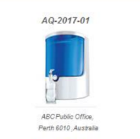——>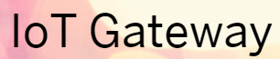 ——> 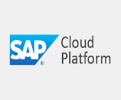——>

Date from the sensor devices (Things) is pushed via the SAP IoT Gateway using HTTP/MQTT to the SAP Cloud Platform (SCP).

The IoT gateway serves as the central proxy for several sensors and actors and collects their data. At the same time, it provides Ethernet, Wi-Fi or GSM-based connectivity, thus making it accessible via the Internet. As such, the primary function of an IoT gateway is to use specific protocols to transfer the data between the sensor-actor network and the business systems via the Internet.

SCP stores this data into the Cloud Databases on HANA. The IoT application uses the data from the databases and uses predictive analytics to provide end users with reports.

Scenario 1)

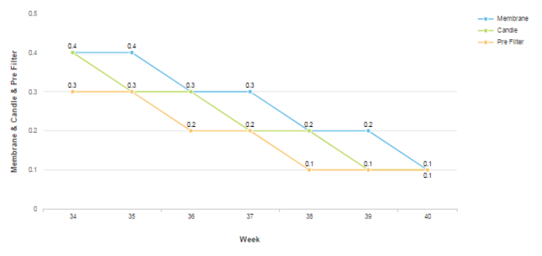

We can see that instead of 52 weeks, system is suggesting replacing the water filters after 40 weeks. This could be because of high input TDS, or high usage.

Scenario 2)

If the IoT device sends any fault information to the IoT application, for example the temperature of water has gone beyond 60 degrees, then immediately a service request is generated with the maintenance team to rectify the fault in the water purifier.